Abstract Format
ª Asako Iwaki, ª Nobuyuki Morikawa, ª Takahiro Maeda, ª Shohei Naito, ª Yuji Dohi, ^{b} Takashi Azuma, ª Ken X. Hao, and ª Hiroyuki Fujiwara
ª National Research Institute for Earth Science and Disaster Resilience, Japan, iwaki@bosai.go.jp
^{b} Geological Survey of Japan, AIST, Japan

Please prepare your abstract by 30 of September, 2024, and submit via e-mail to proceeding@bosai.go.jp . Abstract should not exceed 1 page. Please include the e-mail address of the corresponding author. The abstracts will be distributed on-site.

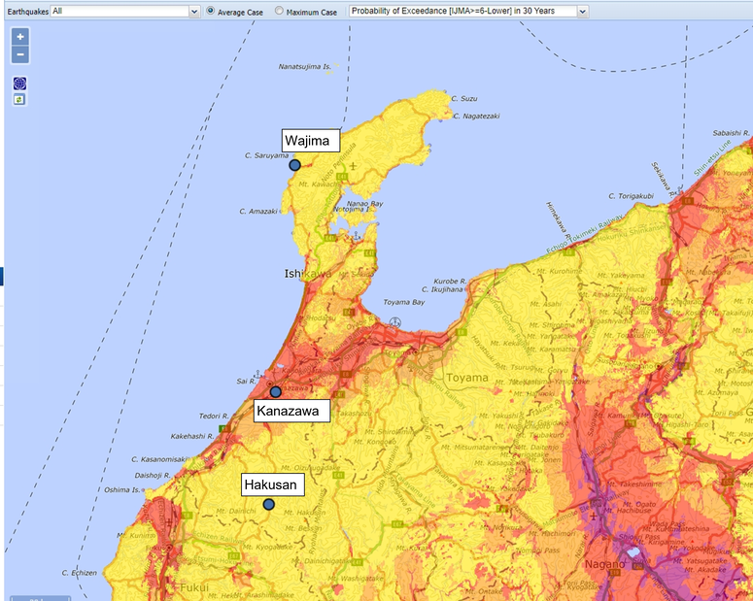
Fig.1 Venue of the meeting and the field trip (NIED 2024).

References
NIED (2024), The 2024 Japan-New Zealand-Taiwan Seismic Hazard Workshop, https://www.j-shis.bosai.go.jp/intl/jp-nz-tw/workshop/2024.html

